#### **Project Objective:**

The project aims at developing a **Customer Management System** in which subscriber and revenue data would be analyzed in detail and effectively managed. In addition, the system will make handling of employee accounts effective and create easy communication between the employees and the administrative team.

#### **Why This System is Needed:**

In today's data-driven business environment, there is a requirement for true understanding of subscribers' behavior and revenues trends for strategic growth. This CMS addresses these needs.

* **Data Analysis for Business Growth**: Helping the businesses analyze revenue trends and subscriber demographics better so that customers can be engaged using such data-driven strategies.
* **Centralized Data Management**: Integration of employee and subscriber data within an integrated system to ensure better consistency in data and minimal fragmentation.
* **Streamlined Communication**: Facilitating better communication between employees and the admin team through structured messaging.
* **Operational Efficiency**: Reducing manual effort in managing data, handling inquiries, and updating records.
* **Enhanced Responsiveness**: Improving the response time to feedback and issues, fostering trust and satisfaction.

#### **Key Features:**

1. **Admin Portal**:
   * **User Authentication**: Admins can log in using an Admin ID and password to access the portal.
   * **Create Employee Accounts**: Admins can create new employee accounts with personal and department details.
   * **View All Employees**: Admins can view a list of all employees, including their details such as department, name, user ID and password.
   * **Delete Employee Accounts**: Admins can search for and delete employee accounts based on the user ID.
   * **Update Employee Data**: Admins can update employee information, including their department, name, and password.
   * **Messages from Employees**: Admins can view and reply to messages sent by employees.
2. **Employee Portal**:
   * **"Message to Admin" Button**: Employees can directly send messages to the admin to report bugs, highlight mistakes, or request updates to their details in the database.
   * **Main Work Section**:
     + **View All Subscribers**: Employees can access and view all subscriber details available in the system.
     + **Add Subscriber Data into the Database**: Employees can upload CSV files containing subscriber data for analysis, streamlining the data entry process.
     + **Delete Subscriber Data**: Employees have three options for managing subscriber data:
       - **Delete All Data**: Deletes all subscriber data available in the database.
       - **Delete Data by Range**: Allows employees to select a specific range of data to delete subscriber data.
       - **Delete Single Data**: Enables data deletion by entering a specific data ID.
     + **Analysis Section**:
       - **Revenue Analysis**: The portal offers six types of revenue charts:
         * **Monthly Revenue Trend (Line Chart)**
         * **Revenue by Subscriber Type (Bar Chart)**
         * **Revenue by Country (Bar Chart)**
         * **Revenue by Gender (Pie Chart)**
         * **Revenue by Device (Bar Chart)**
         * **Revenue by Age Group (Bar Chart)**
         * *Filters Available*: Analysts can filter data by country, subscription type, and age group from the sidebar.
       - **Subscriber Analysis**: The portal provides five types of subscriber charts:
         * **Subscriber by Gender (Bar Chart)**
         * **Subscriber by Age (Bar Chart)**
         * **Subscriber by Device (Bar Chart)**
         * **Subscriber by Country (Bar Chart)**
         * **Subscriber by Plan (Bar Chart)**
         * *Filters Available*: Analysts can filter data by gender and device type from the sidebar.
3. **Data Analysis in the Employee Portal**:
   * **Revenue and Subscriber Analysis**: The main utility of this system is revenue and subscriber analysis. There are numerous analytical charts for various analyses with which the employee can know the trends and patterns for strategic decision-making.
   * **Message Response Analysis**: Tools for tracking the time taken to respond to employee messages and improving response processes.
   * **Employee Performance Metrics**: Analyzes key performance indicators (KPIs) like the number of messages handled and response efficiency.
   * **Feedback Trends**: Insights into common feedback and inquiries received, enabling proactive responses.

#### **Technologies Used:**

* **Frontend**:
  + **Streamlit**: The primary framework for creating the web-based interface. It enables quick and interactive development with minimal configuration.
* **Backend**:
  + **Python**: Used for writing the logic behind the system, including user authentication, database operations, and form handling.
  + **MySQL**: The database system for storing and managing employee details and customer messages. It handles the backend data operations like account creation, data retrieval, and message management.
* **Security**:
  + **Email Validation**: Regular expressions are used to validate email input, ensuring that only valid emails are processed.

#### **System Workflow:**

1. **Admin Login**:
   * Admins enter their credentials (Admin ID and password) to log into the system. Upon successful login, they can access administrative features like creating and managing employee accounts, viewing employee details, and replying to employee messages.
2. **Employee Account Management**:
   * Admins can create new employee accounts by specifying details such as department, name, user ID, and password.
   * Employees can be searched by user ID, and their accounts can be deleted or updated as required.
3. **Employee Communication**:
   * Employees can fill out a contact form to send messages to the company. These messages are stored in the database.
   * Admins can view, respond to, and update the status of these messages.
4. **Message Reply**:
   * Admins can view the details of each employee message, provide a response, and update its status, ensuring effective communication.
5. **Database Operations**:
   * Employee and subscriber data are managed through a MySQL database. Each operation (create, update, delete) is securely handled via SQL queries executed with Python.

#### **Detailed Components:**

* **Admin Portal**:
  + **Login**: Admins use credentials to access the portal for managing accounts and communications.
  + **Account Management**: Admins can create, view, update, or delete employee accounts.
  + **Messages**: Admins can view and respond to messages and update their statuses.
* **Contact Form**:
  + **Message Collection**: Employees fill out a form with their name, contact details, and message.
  + **Message Validation**: Ensures valid email entry, and data is saved to the database.
  + **Confirmation**: Users receive a notification upon successful message submission.
* **Employee Message Analysis**:
  + **Response Time Tracking**: Records the time taken for admin responses, generating average response time reports.
  + **Performance Insights**: Identifies efficient employees and those requiring additional support.

#### **Screenshots Section:**

To provide a visual overview, important screenshots of the system’s key components will be included to illustrate:

* **Home**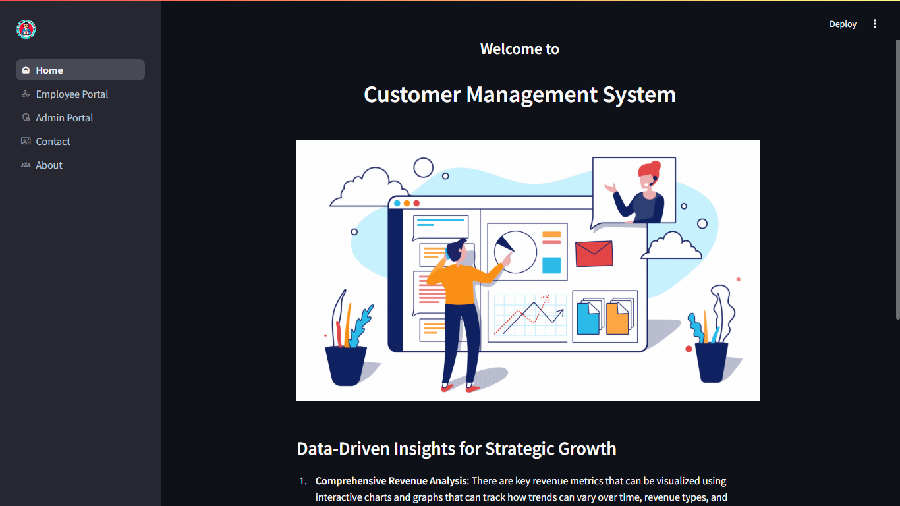
* **Employee Management Dashboard**

[**Employee Portal Screenshot**](https://drive.google.com/file/d/1w10j720pmlk7ZfxgiEXVxXe1XFQ02ka8/view?usp=sharing)

* **Admin Login Page**

[**Admin Portal Screenshot**](https://drive.google.com/file/d/1TQqSoyWnLAz74ilN4a9_TzNoZCWMZPfN/view?usp=sharing)

* **Contact Us**

[**Contact Us Screenshot**](https://drive.google.com/file/d/1GKxLOtt_wFsuMKDRLltWSUJvef6x1SV1/view?usp=sharing)

* **About Page**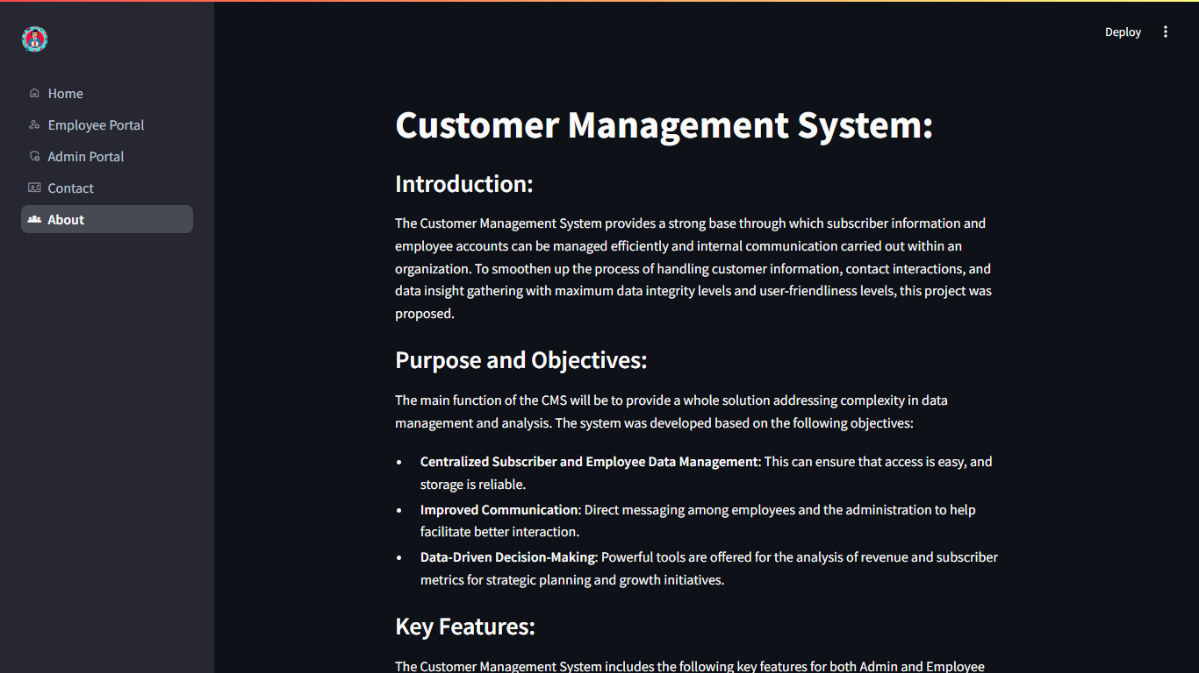

#### **Conclusion:**

The **Customer Management System (CMS)** offers a comprehensive solution for managing subscriber data, analyzing revenue and demographics, and handling employee accounts and communication. With integrated analysis features, it supports informed decision-making and operational improvements. This system not only enhances data management and communication but also equips users with valuable insights that drive strategic growth and customer engagement.